오토마타 예비 프로젝트 1-2 보고서

20130570 전철호

제출물: 소스코드, 실행가능파일, 간단한 메뉴얼

소스코드: Please refer to main.py. It is within the zip file I attached, or you can clone it from https://github.com/adobecs5/automata2015/tree/master/2

실행가능파일: please refer to main.py

(how to execute: regardless of OS, open your terminal and type “python3 main.py”)

(This code needs python3 to run. It is coded with python 3.4.3)

간단한 메뉴얼:

1. **Start the program by typing “python3 main.py” on the directory you downloaded the files.**

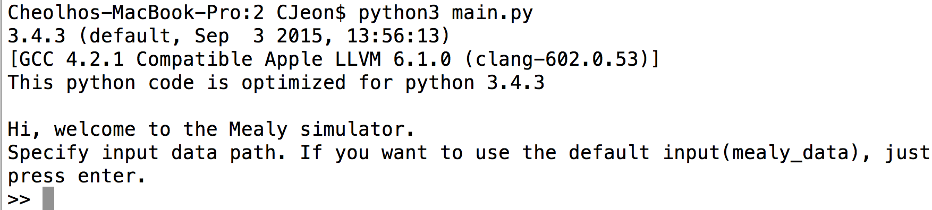

specify datapath.

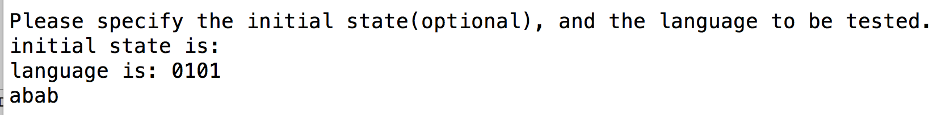

type initial state(optional) and give language to be evaluated.